EXPERIENTIAL LEARNING GROUP REPORT
MADIPALLE VILLAGE, WARANGAL
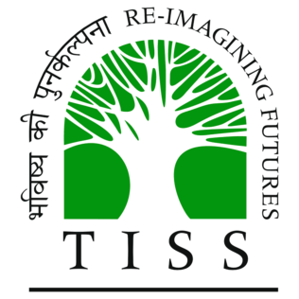

SCHOOL OF LIVELIHOODS AND DEVELOPMENT
TATA INSTITUTE OF SOCIAL SCIENCES
HYDERABAD

Group 7
- Balu NV
- Linu Eldho
- J Manjusha
- Meghana Myadam
- Nidhi Joshi
- Sriaparna Reddy
- Samridhi Nath
- Vikas Peddi

Introduction
Following is a report of experiential learning at Madipalle village, a village in Hasanparthy Mandal in Warangal district of Telangana. This experiential learning was done in collaboration with Palle Srujana, a voluntary organisation. The report enlightens the group’s experiences in a four day stay at the village.
Objectives
The objective of this study is
- To understand the socio economic and cultural realities of Madipalle village
- To know about the means of livelihood of the people
- To get a better idea of social structures, public services, infrastructure, access to education and health care, and political structures of the village
Method of Study
Following methods have been used to conduct the study:
- Collection of Secondary Data
- Observation
- Village Monograph
- Interview
- Focus Group Discussion
Activities Undertaken
Day 1: Visited one of three Anganwadi centers, interaction with Sarpanch and locals, visit to rice and palm tree fields, interaction with shopkeepers, interaction with farmers
Day 2: Visit to panchayat office, interaction with panchayat secretary and other officials, visit to remaining Anganwadi Centres, interaction with cotton farmers, visit to SC colony
Day 3: Visit to Zila Parishad Utthama Paathshala, interaction with locals of Ambedkar colony, visit to VRO office and interaction with VRA
DAY 4: Interaction with self-help groups and Mahila Sangam, visit to IKP centre
Village Profile
Madipalle’s current population is 3000 approximately out which the recent voter list consisted of 1966 voters. Following is an elaborate profile of the population according to 2011 census:
- Total no. of households - 616
- Total Population - 2319
- Total no. of males- 1166
- Total no. of females- 1153
- No. of children (0-6 age)- 179
Caste composition:
- Backward caste- 1820
- Schedule caste- 482
- Schedule tribe- 17
- Other castes- 2

Backward castes (BC) population is prevalent in the village.

VILLAGE | MADIPALLE
MANDAL | HASANPARTHY
DISTRICT | WARANGAL
REGION | TELANGANA
LANGUAGE | TELUGU
STATE | TELANGANA
LOK SABHA CONSTITUENCY | WARANGAL PARLIAMENTARY CONSTITUENCY

The village encompasses about 3001 acres of which 2000 acre land is cultivable land. Most of the people in the village relied on agriculture as an occupation.
Social Structure
Caste
The village has 9 castes:
- Chakali: Washerfolk caste
- Golla: Cattle breeder and backward peasant caste; also called Yadavas
- Gouda: Toddy-tapper caste
- Madiga: Scheduled caste
- Mala: Scheduled caste
- Mangali: Barber caste
- Reddy: Dominant peasant caste
- Waddera: Caste of traditional well-diggers and stone-cutters
- Yerukala: A semi-nomadic tribe involved in basket-making and pig-rearing
Of these 9 castes, the Goudas and the Gollas constitute the majority of the village’s population, the Mala and Madigas are considerably numerous, the Reddys are few, the Waddera and Yerukala castes have 2-3 families each in the village.
One of the important reasons that we chose to pursue the caste question deeply was that the village was divided into clearly demarcated areas of inhabitation, differentiated on the basis of caste. On the first interaction we had in the village, with an Anganwadi worker, it was found that there was an ‘SC colony’. Upon further inquiry, we found 4 major localities or wadas:

- Kothawada - Gouds
- Gollawada - Gollas
- SC Colony - Madigas
- Ambedkar Colony - Malas
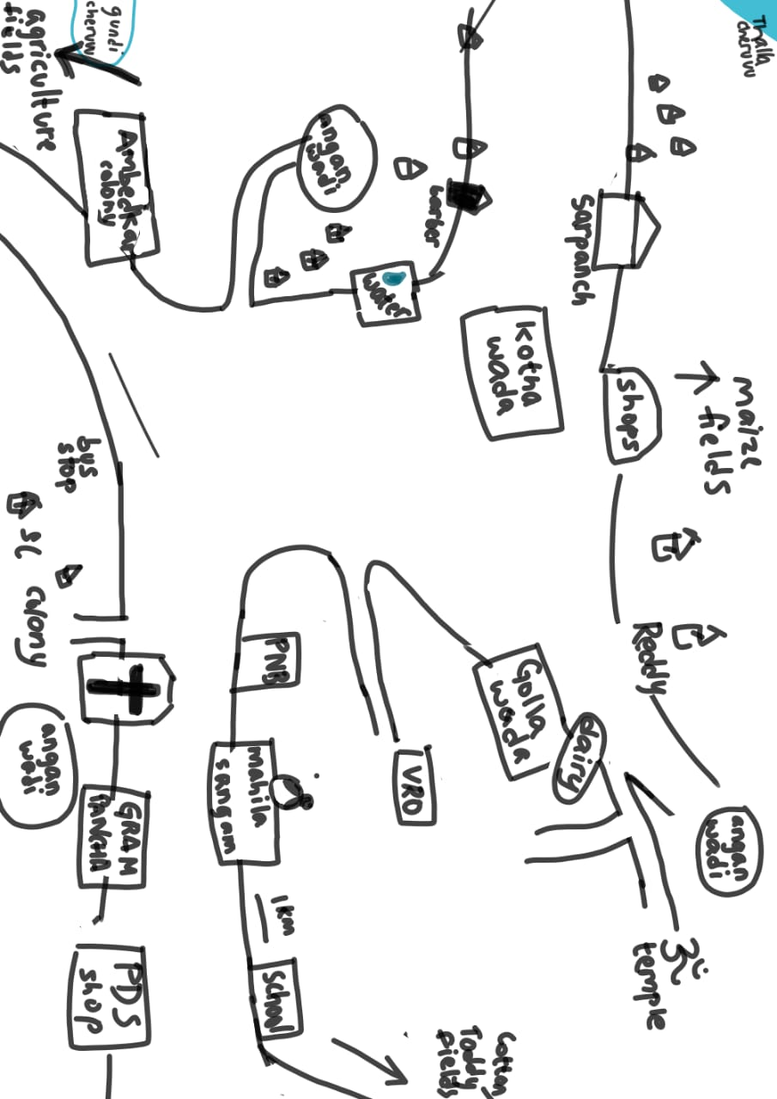
(Above picture is the physical map of the village drawn by the team with the help of villagers)
Villagers from all the 4 localities were asked why there was such demarcation. All of the respondents pointed to certain historical discriminatory practices as a basis for it. All of the respondents also explicitly stated that even when such differentiation exists, there are no discriminatory practices in the village. However, our team did identify that the identity of the villagers is still heavily influenced by their caste.
This finding can be understood further by deconstructing an interaction we had with one of the villagers, Priyanka.
On the 2nd day (26th November 2019) of our stay in the village, 3 of us from the team spoke to Priyanka from the SC colony. We started the conversation by introducing ourselves and proceeded to ask general questions about her everyday activity and livelihood. After we got an understanding of the lives of her and her family, we asked about the division of the localities:
Team member: “Why is it that there is an SC colony, a Gollawada, etc. Why do people of different castes live in different localities?”
Priyanka: “It’s not a product of the present times. It has been like this in the past due to untouchability and discrimination and that’s how such colonies were formed. But, now we do not have any such discrimination in the village.”
Team member: “Do people from other castes live in your colony?”
Priyanka: “There is one Goud family but on the edge of the colony.”
Team member: “Would you or other SC people go over to Kothawada?”
Priyanka: “Why should we go outside this colony [SC colony]. After all, no matter what happens, we have our people. SC people will look out for SC people. Will the Gouds look out for us the same way?”
(This is the translation of a conversation that was carried out in Telugu)
Another similar instance took place when we went to an Anganwadi center on 25th November 2019.
Rangamma, an Anganwadi worker there (“aaya”), also remarked,
“If I have a fever or illness, and my entire caste is here, why will I go there or elsewhere?”
(This is the translation of an exchange that happened in Telugu)
These instances point to two things: a) the role of caste in shaping people’s identities and, b) the sense of belongingness and security people associate with their caste.
It was also found by the team that the average resident of Madipalle was highly conscious of their own caste and the caste of other people in the village.
Caste Endogamy
We found caste endogamy in Madipalle to be rigid. We found that there are no instances of inter-caste marriages in the village. Inter-caste relationships are met with scorn in the village and are not accepted by the families of the parties. In the past, there have been cases of elopement due to such unacceptance.
Cremation
There is a cremation ground beside the government school in the village. The team found that the cremation ground can and is used by all communities without any restriction. Cremation and burial grounds have reportedly been sanctioned by the MRO.
Caste and Occupation
Of the 9 castes in the village, caste-based occupations are predominantly practiced by the Gouds and the Gollas. The Gouds have a virtual monopoly on their traditional occupation, toddy-tapping. Additionally, they are also involved in agricultural labour. The Gollas also follow their traditional occupation of cattle-rearing, but many of them have diversified into agriculture. The Gouds and the Gollas have also diversified into occupations like driving, etc. Many of the Gouds and Gollas own agricultural lands.
The Mala and Madiga castes do not practice their traditional occupations like leatherwork or artisanal work, etc. Few of them hold agricultural lands. These castes are predominantly involved in agricultural wage labour and other daily wage labour like carrying bastas, construction work, etc. According to the Gram Panchayat office, all of the 4 safai karamcharis in the village are from SC communities. As safai karamcharis, their labour includes cleaning drains, roads, etc. from time to time.
The Reddy castes have agricultural landholdings and lease them out for agriculture. The Reddys have out-migrated to towns and cities and either leased their lands or sold them to others.
The other caste groups like the Wadderas and Yerukalas do not practice traditional occupations. These castes are involved in agricultural labour, have grocer’s shops, etc. The Yerukalas are a semi-nomadic tribe but in Madipalle, they are homogenized into the village and have adopted the way of living of the villagers.
Caste and Land-ownership
One of the limitations of this study is the lack of caste-wise land ownership data. The Village Revenue Officer and the Village Revenue Assistant were approached but they did not have such data. Therefore, the team had to rely on oral accounts of many villagers. We found that, historically, the Reddys (even now referred to as Doras) had owned majority of landholdings. Such concentration of resources has been diluted now due to the migration of Reddys out of the village.
Endowments
According to the Gram Panchayat Office and the villagers, two lakes in the village - Gundi Cheruvu and Thalla Cheruvu, which come under government property are both registered under the SC communities. They get paid by fisherfolk who do fishing there. All the proceedings are distributed uniformly to people in the SC community by an elected body of SC people.

Resource Mapping

Livelihood
In Madipalle village, 70% of the population is involved in farming as a way of earning a living. Small-scale farming, fishing, raising livestock and non-farm activities are some of the common livelihoods that people of the village survive on. Some households have diverse sources of income-earning activities. They follow agriculture and also their hereditary, caste-based occupation. Interestingly, the farmers eat the crops they grow and drink the milk from their own cows and buffaloes.
Following are the different types of rural livelihoods that villagers follow:
- Agriculture
- Livestock rearing
- Non-farm activities

Agriculture
Agriculture is the main occupation of the people of Madipalle village. The total cultivable land in the village is 2200 acres. The land mainly consists of Black and Red soils. The main crops grown are paddy, cotton, maize and other vegetables. Out of 2200 acres, paddy is grown in 1200 acres. Cotton and maize are grown in 500 acres each.
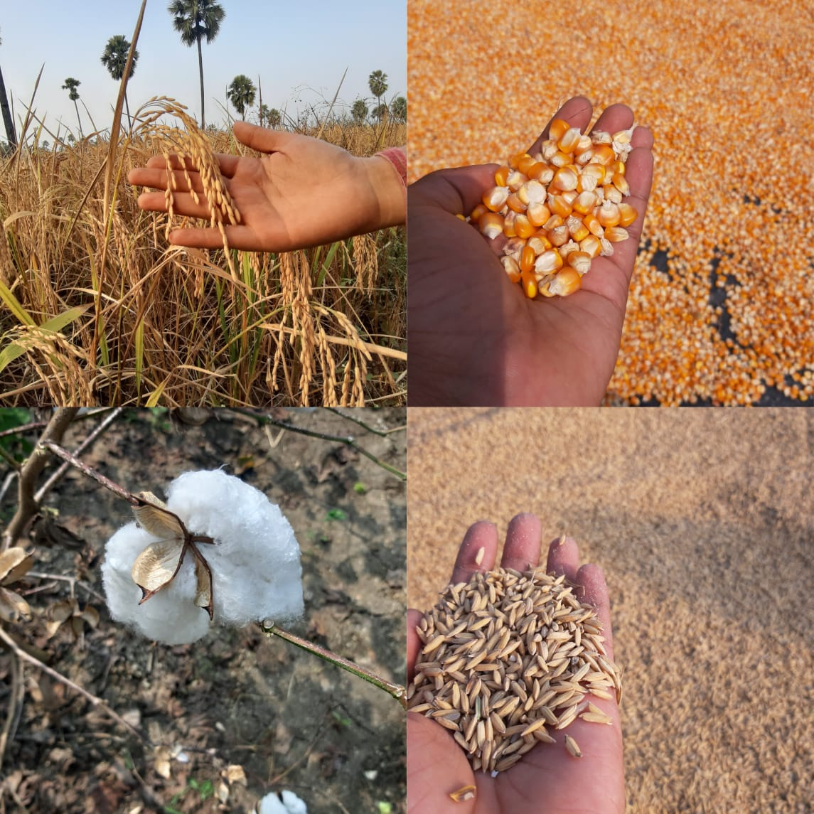

During our visit to the Madipalle village, it was the harvesting season in the month of November. The farmers were harvesting their paddy and making it ready for sale. The machines they used for harvesting the crop cost them Rs.1800 per hour. We found that the crop duration of the paddy is 100 days. For each acre of land, they get nearly 20 quintals of paddy. According to a farmer, Chinta Ramesh, the next season i.e., Rabi season, the yield decreases due to continued farming and water availability. The yield falls to 12 to 15 quintals per acre of land.
The village has sufficient water for agriculture and household uses. The village has two lakes, namely, Gundi Cheruvu and Thalla Cheruvu. Villagers were seemingly content with the water facilities.
Indira Kranti Patham (IKP)
Paddy is procured by the government through the paddy procurement centres under Indira Kranti Patham (IKP) established by government. The IKP centre in Madipalle was established 2 years and is managed by the women from Self Help Groups of the village. They organise IKP and procure paddy. Farmers from the village sell their crop to the IKP centers directly without the involvement of middlemen.
Government is giving Rs. 1815 per Quintal as Minimum Support Price (MSP) for paddy. When the farmers had to sell to private traders, payments were irregular. The farmers stated that the situation is better now that there is an IKP centre in the village, and the payments are prompt.
All the farmers we interacted with have expressed contentment with the IKP centre.
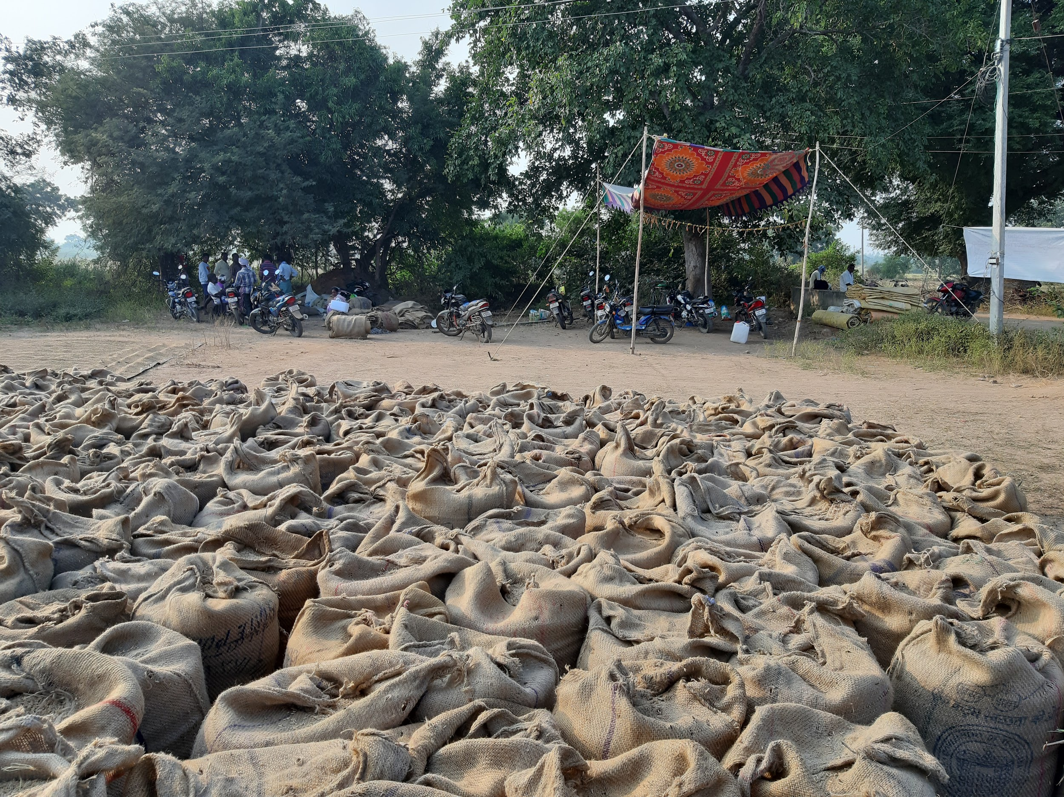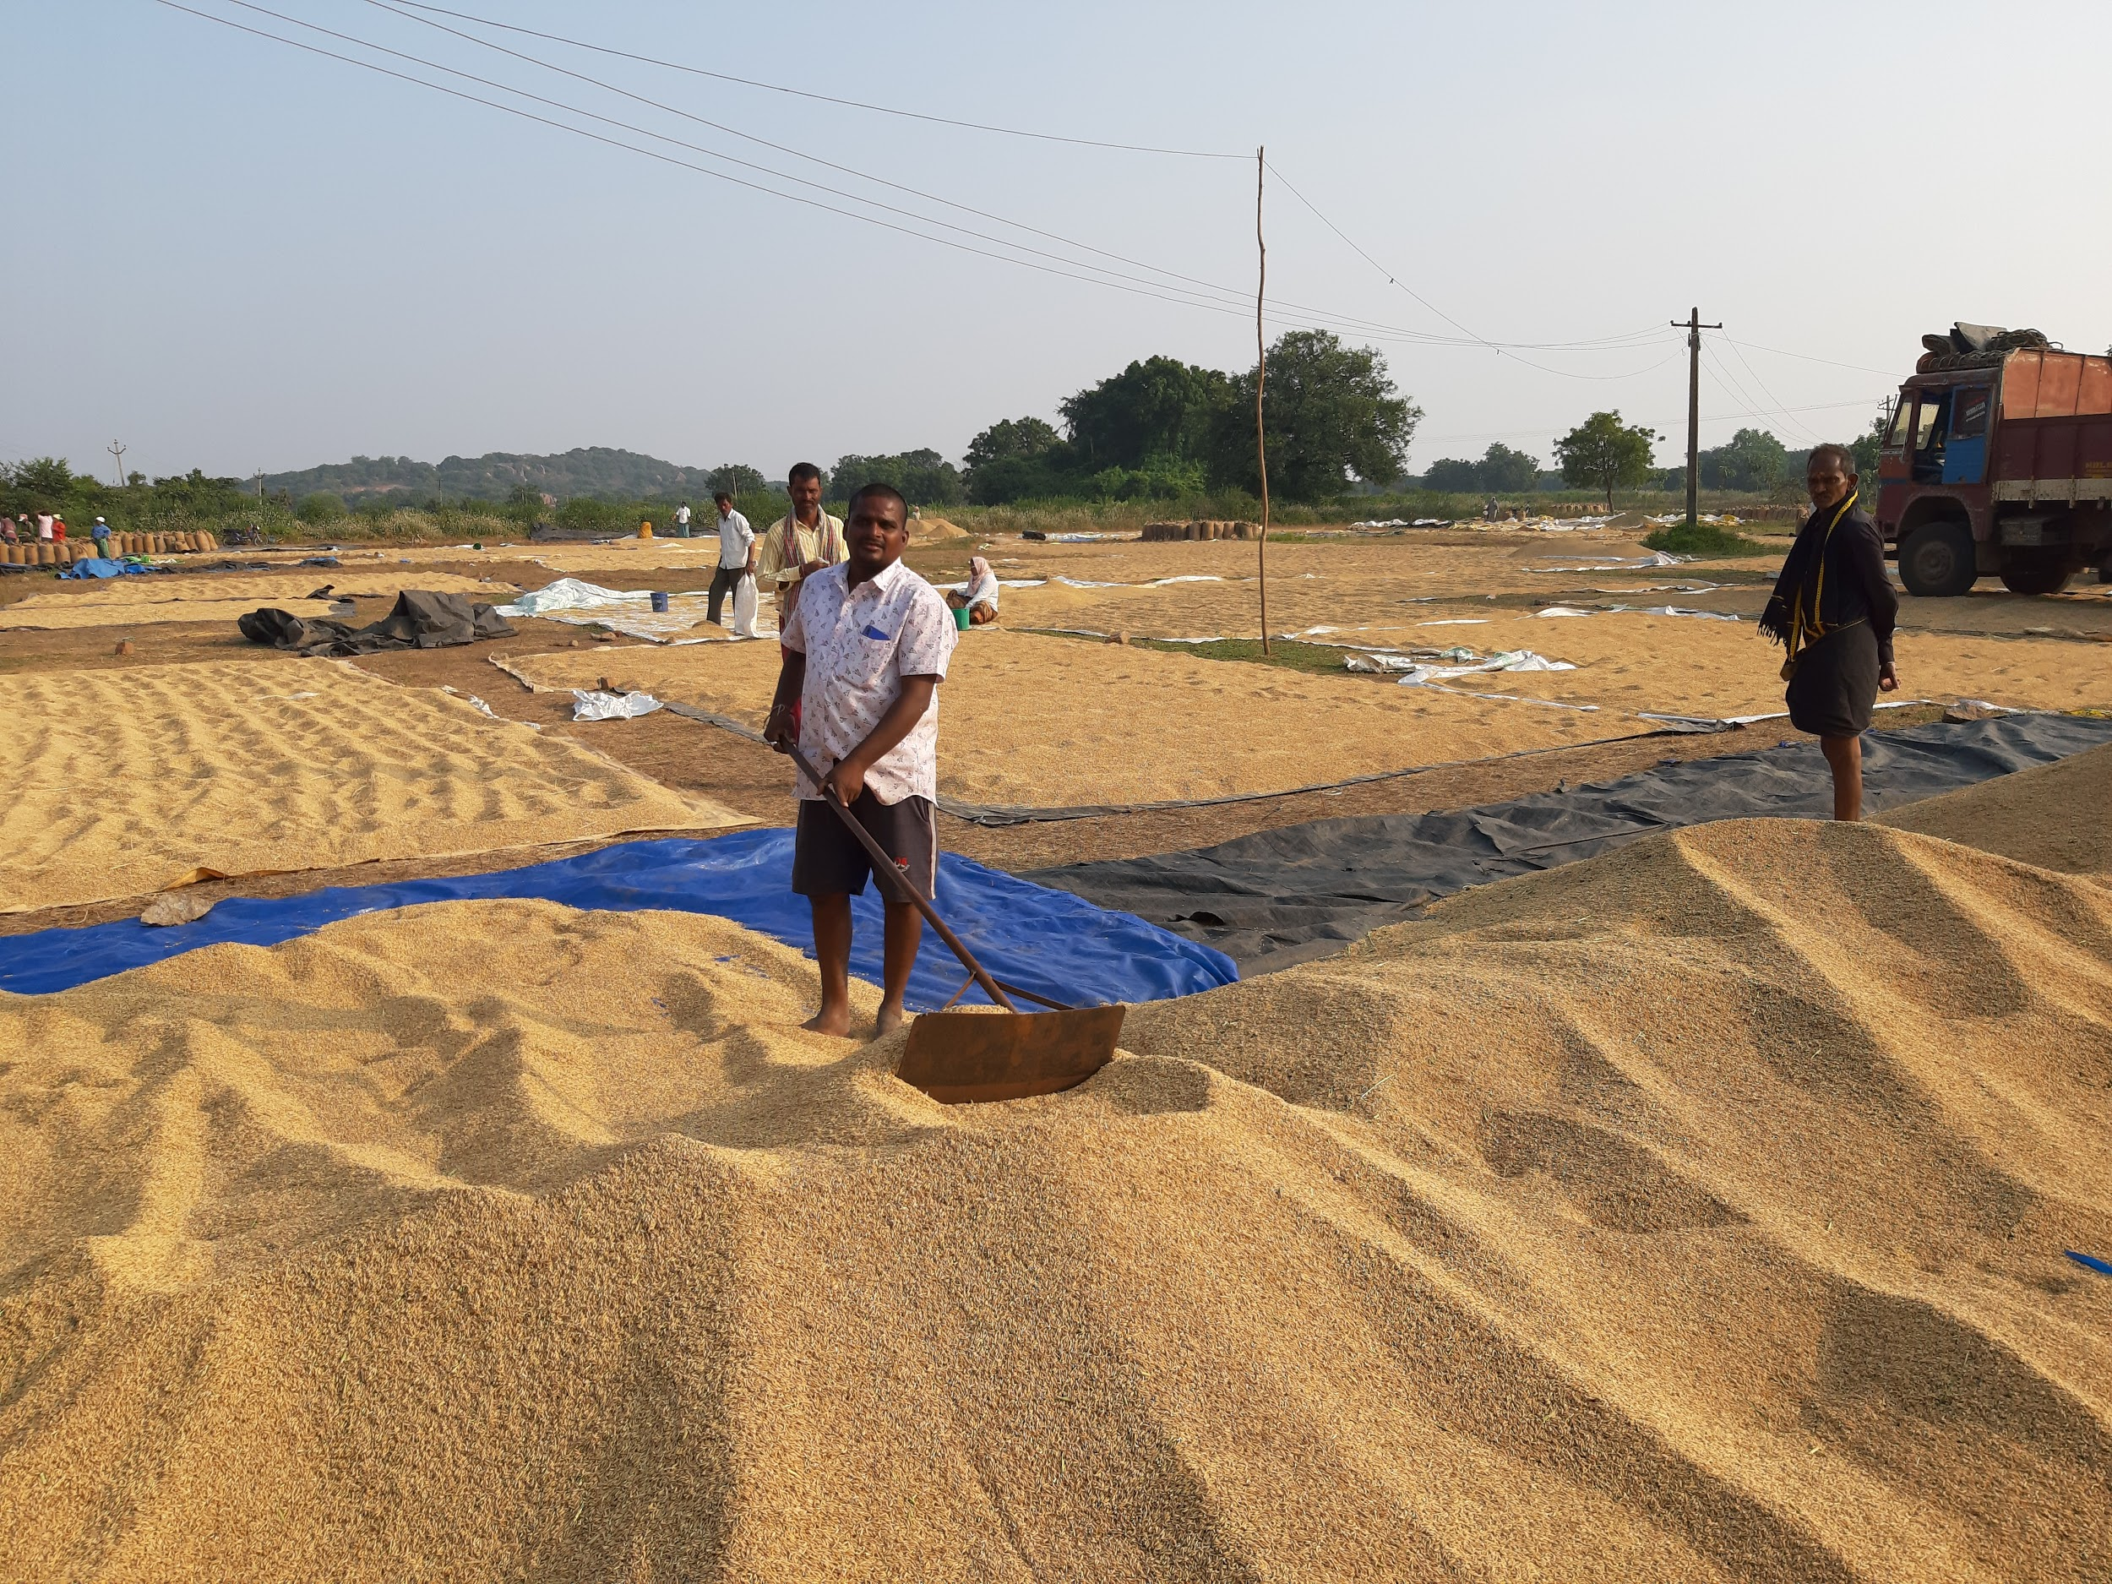

Agricultural Inputs
These are the main agricultural inputs required for farming.
- Labour
In the village, most of the people are agricultural labourers and people from other villages fill the shortages in labour when the need arises.
Agricultural labourers are those people in villages who work as labourers in fields and get daily wages. Their work is temporary and seasonal. They don’t get work for 365 days. They diversify into other occupations when they don’t get work. Some people also migrate to cities in search of jobs. There is also one case of reverse migration, where a person worked for 7 years in Hyderabad as a cab driver and quit the job and came back to the village to do farming.
- Seeds and Fertilizers
The farmers buy seeds and fertilizers from Hasanparthy Mandal, which is 10 Kms from Madipalle village.
- Harvester machines and tractors
They require tractors to harvest and also to carry materials. They cut the crop through the harvester machines which are available in the village. The charge for harvester machine for 1 hour is Rs. 1800.
- Ploughing :
Ploughing is done by cattle and tractors. Work involving ploughing and harvesting is only done by men.

Difficulties observed
- It was noted that the input cost is increasing due to abrupt climatic conditions. Due to the rainfall last month, the field was filled with water and the harvester machine is taking more time to cut the crop. Therefore, the harvester machine owners are charging more money for cutting. Usually, the cost is Rs.1800 per hour but now they are charging Rs.2500 per hour.
- Some farmers said that they don’t need the Rythu Bandhu scheme. Instead, they want the government to increase the Minimum Support Price (MSP).
- Some farmers take land from landlords for farming and pay the rent. In this case, the tenant farmer is not getting the Rythu Bandhu money.
Livestock Rearing
Livestock includes domestic animals such as Cattle, Goat, Sheep, and Hen.
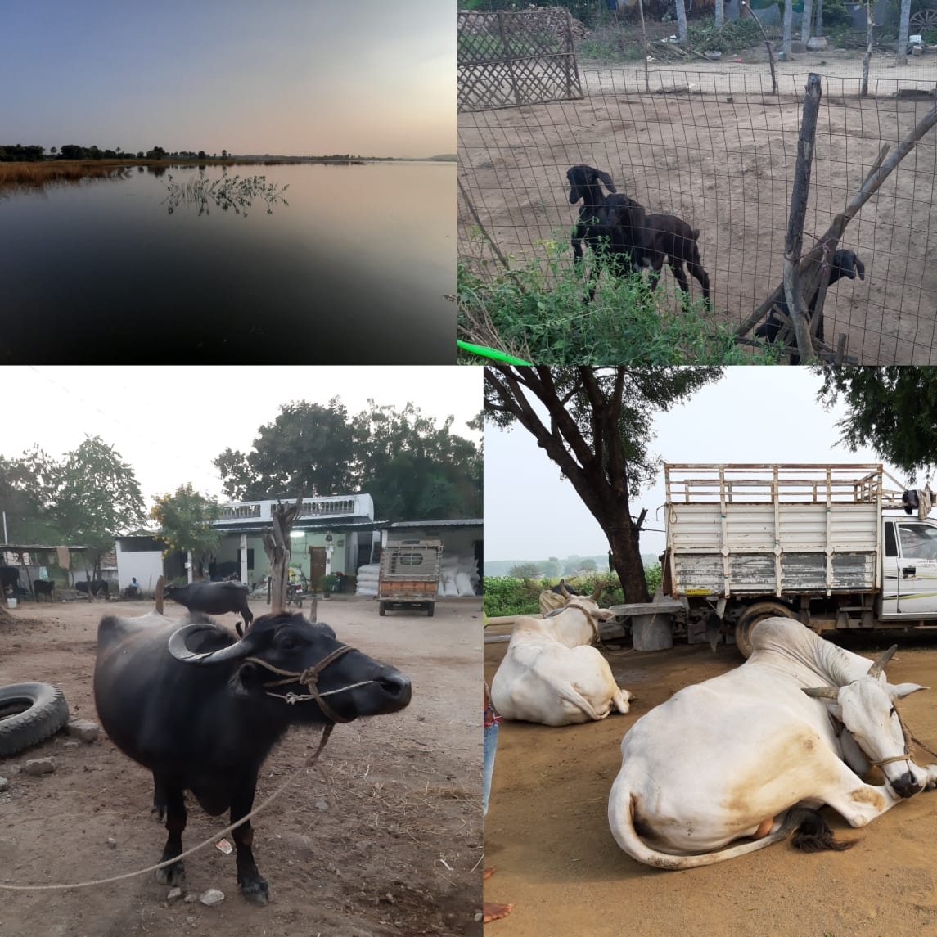
In Madipalle village, major portion of livestock is cattle rearing. Cattle rearing is an important economic activity for ploughing and milk production. Almost every house has two or three buffaloes. Everyday morning and evening they take the milk and sell it to the dairy centre in the village. They get payment from the dairy centre daily depending on the fat content in the milk. The milk from there goes to Mulkanoor dairy centre where the processing of milk done. The fodder for cattle is taken from their own farms like grass and rice bran.
Goat and Hen are also reared by some families in the village.
Non-farm Activities
Non-farming activities are those which do not include farming as a source of income. These include construction, transportation, communication, trade and mining among others. Non-farm activities in rural areas play an important role in generating employment for people. It may also prevent the migration of rural people from rural areas to the urban, due to the shortage of job opportunities. The rural nonfarm activities receive limited resources and engage a larger section of workers.

Infrastructure and Sanitation
Electricity
Every household in the village of Madipalle has an electricity connection with 24 hours power supply. There are no serious power outage issues in the village as remarked by its residents. This enables people to use motors and other electronic equipment for farming and household activities. Even the remote paths of the village are installed with street lights at regular intervals. Out of the 37 lakhs provided for the village for its annual expenditures in 2019, 10% is stipulated for the installation and management of street lights.
Water Facilities
Regarding the supply of water, the Bala Vikasa plant remains as the major source of drinking water for the village. It is a mineral water plant that functions on reverse osmosis technology. The machine capacity of the plant is 1000 liters per hour. The pipelines of Mission Bhagiratha are under construction and 90% of the work is done. However, it has not been operationalized yet. Some people have borewells in their personal properties which serves as a source for agricultural water requirements. Also, primary sources of irrigation are the two lakes situated in the village namely Gundicheruvu and Thallacheruvu. It is open to all communities for irrigation purposes.
Sanitation
A couple of years ago, the village has been declared as 100% defecation free. Under the Swachh Bharat mission, every household has been given an amount of Rs. 12000 as two installments for the construction of toilets. In our observation and interaction with the villagers, we came to know that around 25 families still don't own a toilet in their house. They claimed that the amount for the construction of the toilet was not yet remitted to them.
The female population is well aware of the concern of menstrual hygiene and the majority of them use sanitary napkins.
Waste Management
There is an open drainage system throughout the village. Due to the lack of proper waste management mechanisms, the drainages are used for dumping waste. There is a multi-utility tractor used in the village for the cleaning, collection and transfer of waste. An amount of 6,20,000 Rupees was spent by the Panchayat for the purchase of this tractor.
Transport
The roads in the village are mostly unpaved. Transportation is a major concern in the village of Madipalle. There is only one bus service in the village, thus the frequency of connectivity is minimum. After 7PM, there are no bus services to the village. This has adversely affected the young population who aspire to work outside the village. There are private vehicles and auto-rickshaws that bridge this gap to some extent.
Other facilities in the village include 2 PDS from where people get food grains and other necessary items. The village is under camera surveillance by 4 CCTV cameras. To facilitate credit requirements, there is a Punjab National bank branch in the village that facilitates withdrawal and depositing.
Healthcare Facilities
Warangal has an HDI of 0.612 and ranks 4th amongst the districts in Telangana. The district has only one Government General Hospital (Mahatma Gandhi Memorial Hospital, Warangal) and 82 sub-centres, 11 primary health centres and 2 community health centres.
While Madipalle is by most accounts and observations a prosperous village with a high population density, there were no health centres, clinics, or pharmacies as such. The closest health centre is at Hasanparthy, the mandal headquarters, which is roughly 15 kilometers away. However, residents reported that the ambulance service (108 service) is prompt and since the connecting roads are in great condition, and emergency services are available within 30 minutes of making the call.
Since there is no pharmacy, over-the-counter (OTC) medication for common conditions like fevers, colds, etc. are available in most grocery stores and petty shops. Medication is also available with the ASHA (Accredited Social Health Activist) workers and is dispensed when needed. The village has 2 ASHA workers, which is slightly deficient as the stipulated proportion is one ASHA worker for 1000 population. These workers are residents of the village and are available at any time. There are also 2 non-resident ANMs (Auxiliary Nurse/Midwife), one of whom was previously a resident but has since moved away. There is a resident RMP (Registered Medical Practitioner). Medical camps are held monthly and are attended by substantial numbers - free check-ups include blood sugar levels and blood pressure levels. Once in six months, more elaborate medical camps are conducted in the nearby Hanamkonda or Hasanparthy, featuring eye check-ups and thyroid tests.
For children till the age of 5, the Anganwadi is the central facilitator for healthcare facilities. Children have their weight tracked on a monthly basis and height every three months to check their Body Mass Index (BMI). Enrolled children are given an egg and a pre-prepared meal daily. Basic kindergarten teaching is also conducted - children are taught alphabets, numbers, nursery rhymes and participate in some activities. The equipment used to track their BMI is provided by the ICDS (Integrated Child Development Services), and the workers go door-to-door once a month every month and keep detailed records of all children. Those found to be malnourished are recommended to seek treatment at an NRC (Nutrition Rehabilitation Centre), the closest of which is at Bhimadevarapalli, in a different district. The children are allowed a guardian to accompany them, who is granted a Rs.100 daily allowance. Children who are unable to seek this specialized treatment are given double rations at their Anganwaadis - however, such cases of malnourished children have not been reported in the village in recent years. For school-going children, health facilities are provided at their Zilla Parishad High School (ZPHS) through regular medical camps and recommended nutrition delivered through the Mid-Day Meal scheme. The food is prepared on the premises and ration is priced at a little over Rs.6 per student. Eggs are provided thrice a week.
For adolescent girls between the ages of 11 and 18, under the Kishor Balika scheme, regular counselling regarding health, nutrition, menstrual hygiene, education, and child marriage are conducted on a monthly basis, along with regular checking of haemoglobin levels. Iron tablets were provided to those who were found to have a deficiency. Every six months, counselling sessions are conducted open to all residents, under the aegis of ICPS (Integrated Child Protection Services) regarding child marriage, education and sanitation. All the female menstruating residents reportedly use only sanitary napkins and burn them for disposal.
Pregnant and lactating women, under the Aarogya Lakshmi scheme, are directed to register themselves at Anganwaadis to avail scheme benefits. They are provided with counselling regarding childcare and nutrition. Their weight is also tracked regularly to ensure health. They are also provided with an egg, a meal and 200ml of milk daily for 25 days a month. Folic acid tablets are provided to those that need it. ASHA workers accompany them for regular hospital visits. To wean children off of breast milk, Balamrutham, a meal replacement powder is supplied by the state to lactating women.
Madipalle has three Anganwaadis, one for 1000 population, sufficient for the 3000 strong population. Each Anganwadi has an average of 7 enrolled children. Each of the Anganwaadis has a trainer and an ayah, and rent for premises is supplied for by the state. The amount, however, is grossly insufficient, at Rs.750 per month. The rent for premises itself often runs over this amount and electricity charges are extra. To conduct certain rituals and activities - such as Sreemanthams and Annaprasanams - the Anganwadi receives a nominal Rs.250 every year. The extra amount is paid for out of pocket by the trainers.
While most residents seemed healthy and well-nourished for the most part, a few of the older residents, especially amongst the Goud community seemed to have developed a bowlegged stature and often painful blisters on their feet due to their toddy-tapping activities, climbing multiple tall and slender palm trees. Several other older residents complained of vision problems and other health conditions that usually accompany aging. One 10-year-old resident also fell victim to Polio. The village also registered 100% immunization and inoculation.
The running theme, however, is the overt distrust the residents displayed for most government-run institutions, including hospitals. The residents cited better quality of treatment and care being afforded in private hospitals over government hospitals.
Education
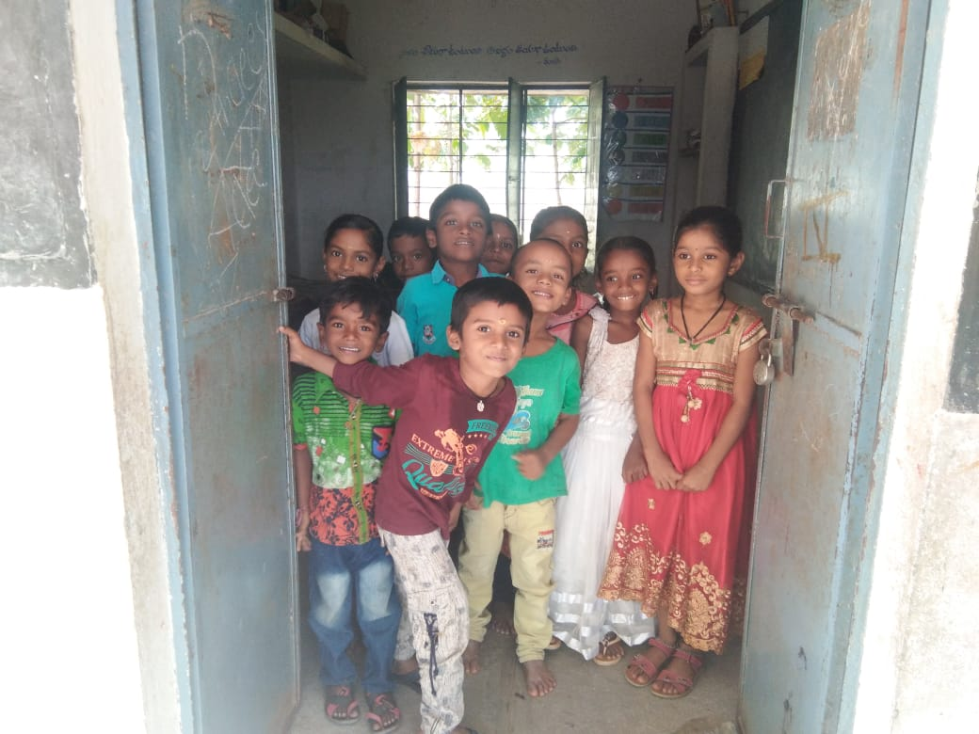
More than half of the population lives in the villages of India. Therefore, it becomes important to understand education as a way to social development, economic growth, and individual growth.
From our observation, the people of Madipalle village appeared to be pro-education. There were hardly any school dropouts witnessed. Most of the people had at least attended the 10th grade. Students were willing to go for higher education opportunities and they considered institutions to be easily accessible as Madipalle lies close to Warangal and other cities.

Visit to a Government School
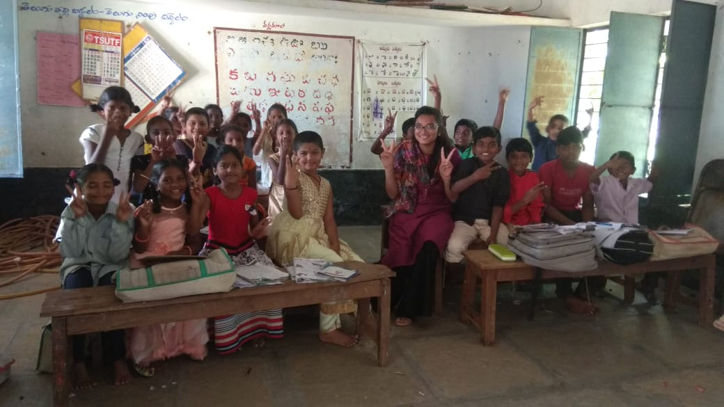
The village encloses a Zila Parishad high school (Zila Parishad Uthhama Paathshala). Divided into two divisions of primary and high school, the primary classes comprise of classes 1st to 5th and classes 6th to 10th form the high school division.

Classes | Male students | Female students | Total
First | 12 | 12 | 24
Second | 09 | 07 | 16
Third | 05 | 11 | 16
Fourth | 13 | 09 | 22
Five | 08 | 05 | 13
Sixth | 03 | - | 03
Seventh | 02 | 07 | 09
Eighth | 10 | 09 | 19
Ninth | 09 | 04 | 13
Tenth | 08 | 07 | 15
 |  |  | 150

Total number of teachers is 8.

Accessibility to students
Transportation
The school is located inside the village. However, students who attend the school from different villages found it difficult to commute due to poor connectivity.
Books and Uniforms
Textbooks and uniforms are provided to the students free of cost. While notebooks are only provided to the primary school students, the higher class students are provided with notebooks by donors.
Absenteeism
The school doesn’t witness significant absenteeism. However, it was noted that during the harvest season there was a dip in attendance. The students miss classes to pick cotton in the fields. Some of them are also given an incentive of 200 rupees for picking cotton.

Fund Allocation
The Telangana government has allocated a total amount of 12500 per year for school expenditure. This fund is allocated on the basis of the strength of the school. However, due to the shift of students towards private schools and increasing relevance of welfare schools, It was noted that due to the insufficiency of funds, the headmaster of the school had to spend personally in order to conduct programmes, buying stationery for the school office, etc.

Awareness programs
Under the Swachh Bharat Mission, the school premises have been kept clean and waste paper-free. Dustbins have been maintained and fixed at multiple places. Toilets have been built. There also exists a system of sanitary disposal.
Female students are made aware of menstrual hygiene and sanitation through awareness programs held every 3 months. Students are provided with toiletries and sanitation kits.
Health checkups are conducted every 3 months.
Under the mid day meal scheme, students are provided nutritional food. Eggs are provided 3 days a week. This food is prepared by Self Help Group workers which is funded by the government. It costs 6.58 rupees per head. These Self Help Group workers are paid after the services are provided.

Observations
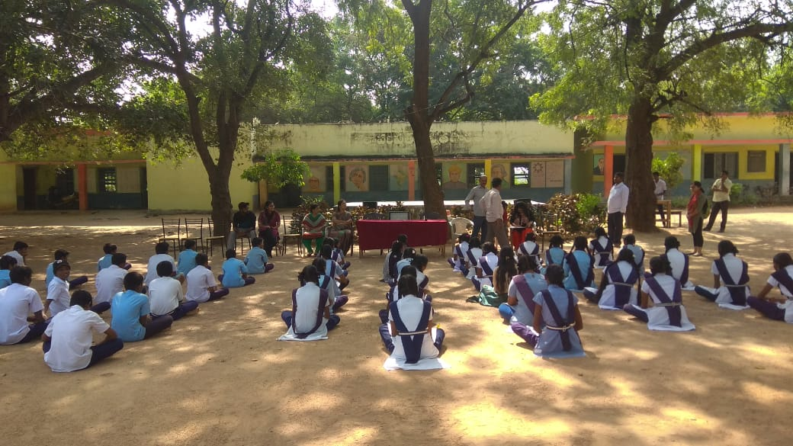
On the whole, the school faces inadequacies in fund allocation, standard and medium of teaching. The school receives a mere amount of 12500 rupees which remains insufficient to fulfill the expenditures. Many a time the headmaster has to spend on expenses from personal funds. This causes a restriction in conducting non-academic activities. The school also faces problems in paying electricity bills.
Despite the primary classes being said to be taught in English medium, it was noted that most of the students were not able to communicate in English.
The high school classes are conducted in Telugu medium. This has been counted as a reason for a dip in enrolment of students in high school. In an interaction with school authorities, it was noted that most parents preferred to send their kids to government residential schools instead.
Another shortfall has been reported in the quality of education and care being provided to the students. Elites of the village send their kids to private schools as they question the quality of education being imparted to their children. Hence, only the poor households end up admitting their children to a government school.
The post of Physical education teacher remains vacant in the school which hasn’t been filled up even after repeated requests from the students.
The students appeared enthusiastic and keen to learn. They are also active in non-academic activities such as sports, music, and dance.

Government Schemes

Central Govt Schemes | State Govt Schemes
PM Kisan | Rythu Bandhu
Swachh Bharat Abhiyan | Rythu Bhima
NREGA | Haritha Haram
 | Mission Bhagiratha
 | Aasara Pension
 | Kalyan Lakshmi

Rythu Bandhu: This is an agriculture investment support scheme in which farmers are provided ₹5000 per acre in each season i.e. Kharif and rabi. The money provided is used to purchase inputs like seeds and fertilizers. It is observed that some farmers said that they don’t have Pattadar passbooks due to which they are not getting any benefit from the scheme. Under this scheme, tenant farmers are also not able to avail benefits because there is no support from the government side.
PM KISAN: This scheme provides financial assistance of ₹6000 in three installments to the farmers as financial benefit from government of India. This money is credited to farmers’ bank accounts directly. It is provided to small and marginal farmers with ownership of land up to 2 hectares.
Haritha Haram: Gram panchayat allocated 10% of the fund to the Haritha Nidhi. This fund is used for Haritha Haram (tree plantation). Under this scheme, each family is supposed to be provided with 6 saplings per year. However, it is observed that not all families are covered under this programme. So far, 1600 trees have been planted on a 4 km road stretch in the village.
Swachh Bharat Abhiyan: Under this scheme, Madipalle village has been declared as a 100% open defecation free village but there are nearly 25 houses that do not have toilets. It is noticed that there are no dustbins in any household.
NREGA: It is a 100 days guaranteed employment scheme. In Madipalle village, 550 people have job cards. (Source: VRO office) They get ₹211 per day as wages. Work done under this scheme includes drain cleaning, plantation, maintenance of nursery and building infrastructure.
Mission Bhagiratha: This project provides safe drinking water to every household. Three water tanks have been installed in the village. So far, 90% of the total work has been completed.
Aasara Pension: It is a pension scheme for senior citizens, widows and physically disabled people. Under this scheme ₹2000 is provided every month to the beneficiaries. There are around 386 beneficiaries getting support from Aasara pension.
Kalyana Lakshmi: This scheme has been introduced to support marriage expenses for financially distressed families. Aim of this scheme is to prevent child marriage. It is observed that there were no cases of child marriage in the village. But, we also got to know that at times this money is also given away in the form of dowry.

Political Structure
Political structure refers to the set of institutions that help the government to function. The political structure of an Indian village is thus the gram panchayat. Gram Panchayat is a form of local-self governance which has been there since 1992. Panchayati Raj act of 1992, which has its ideological roots in Gandhian thought, addressed the need for decentralization and the institution which paved the way for the decentralization process in the village is grama panchayat.
According to the act, there is a three-tier structure in the sense that a voter has to elect three members. First, to his local constituency in the village known as the ward, then to the block panchayat and finally to the district panchayat. Madipalle had 11 wards and the elected ward members form the legislature headed by Sarpanch and assisted by Up-sarpanch. The Panchayat Secretary formed the executive head and is assisted by Village Revenue Officer to take care of the administrative responsibilities.
The Sarpanch of Madipalle village is a woman. There is a 33 percent reservation for women in the Gram Panchayat but she only acts as a nominal head. She attends all the meetings but most of the other works are done by her husband. The villagers also identify him as the Sarpanch. This defeats the whole idea of giving political representation to women. The same gender relations which the reservation is trying to break is thus reinforced in a new way. The Panchayat Secretary is also a woman but, unlike her legislative counterpart, she has more say on her powers and carries out all her responsibilities by herself. The Village Revenue Assistant is also a woman and carried out all her responsibilities like the Secretary.
The Gram Panchayat did not seem to work in an efficient way as our efforts to meet the officials on the first day went in vain as there was no one in the office. A villager who wanted to meet the officials also faced the same response as he went back without any solution. The tilak on Ambedkar's picture was all which we found on the first day. It is ironical that Ambedkar who was a staunch critic of Hinduism, after his death, is respected using the same religious symbols he was against all through his life.
It was also known that they organize to keep Gram Sabha meetings throughout the year. However, not many people in the village attend it. Although the panchayat office was not open in all days the basic functioning, as it is told, was smooth.
From the meeting with the Panchayat Secretary on the second day, it was found that there is a lack of smooth devolution of funds. The devolution of the funds acted as a barrier to the whole decentralization process as a timely flow of funds is a necessity for the efficiency of the Gram Panchayat. There was no smooth flow of funds from the higher administrative levels. The government workers in the panchayat did not receive salary for a period of 11 months and the Sarpanch had to meet all the expenses during this period.
During our interactions with the Anganwadi workers, it was found that there was no smooth flow of funds as the Anganwadi workers had to meet the expenses of the rent from their own pockets. The government schools also lacked adequate funds which affected their efficiency. The lack of funds acted as a barrier in all the institutions and prevented the smooth functioning of the same.

Observations and Reflections
- There were two foci of identity formation in the village: a) caste and, b) village. Residents had a strong sense of belonging to the village. During our interaction with Priyanka, she remarked, “Our village is the best village. There is no better village.”
It is interesting to note this because her identity was also heavily based on her caste.
- Participation of women in village-level institutions was found to be passive. Even though the Sarpanch, Panchayat Secretary and VRA are women, there was a perception that women cannot fulfill all responsibilities and requirements. Hence, it seemed normal to the villagers that the Sarpanch’s husband carried out most of the responsibilities and was also referred to as the Sarpanch. This was so pervasive widespread across the village that even we started referring to him as the Sarpanch, unknowingly.
- During our interaction with the Anganwadi teachers, we found that they carried out awareness programs for pregnancy care and neonatal care. These programmes needed the participation of men in the family. However, very few men in the village had participated in such programmes. It is suggested that better methods be employed to ensure a higher participation rate of men.
- There was a clear division in the type of work done by men and women in agriculture. Barring ploughing, all other farm activities like threshing, weeding, picking cotton, harvesting paddy were all done by women. Men did not engage in such work.
- There were huge wage differentials between men and women for agricultural labour, with men earning around 350 Rupees and more, and women earning around 250 Rupees.
This rural visit has been a rich learning experience and has exposed us to life in the village. The villagers were warm and keen to talk to us. One thing that has left the entire team amused is the trusting nature of the villagers who accommodated us, fed us, gave us tea, and humoured us.

